

Dr. James, Bradford inc.
2016-02-07
Dr. Bradford
69160 Hernandez Walks Suite 401, East Alexland, AK 10045
Phone: 3867454174
Fax: 9140845843

Re: Briana, Miller
PHN: 8721657376
Birthdate: 23-Aug-2001
Address: PSC 5779, Box 5760, APO AA 80472
Patient number: 3060620184

To Whom It May Concern:

This is a medical letter to state the above patient is pregnant with expected delivery date of 23-Aug-2025. Hoping this information is satisfactory for your requirements.

Thank you.

Sincerely,
Dr. James, Bradford
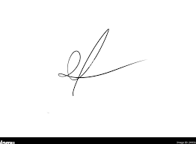
FRCS© NCMP
Clinical Assistant Professor, UBC
Department of Obstetrics and Gynecology SMH

